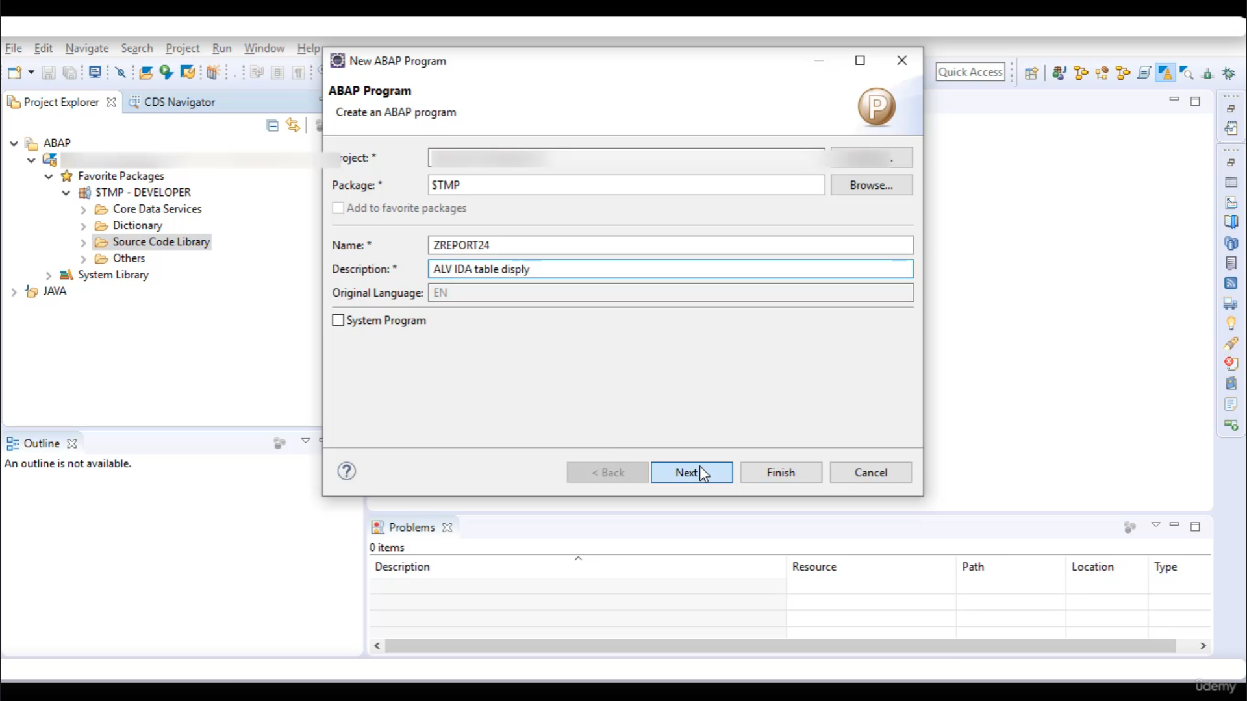

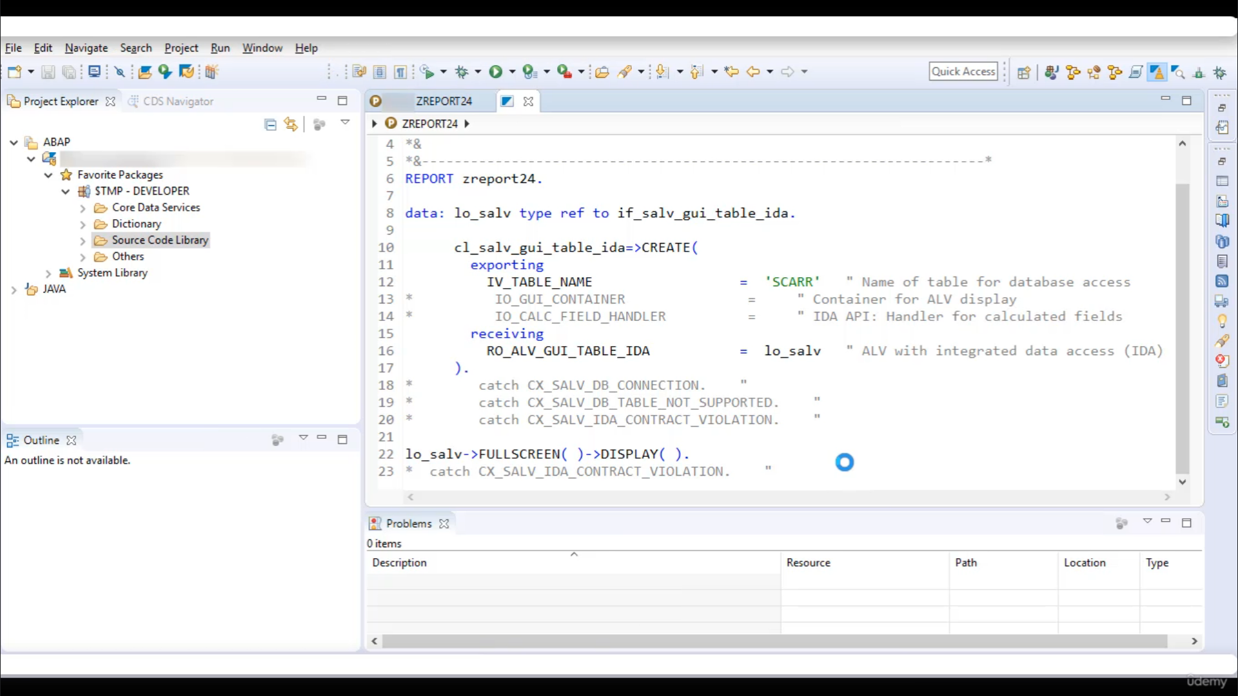

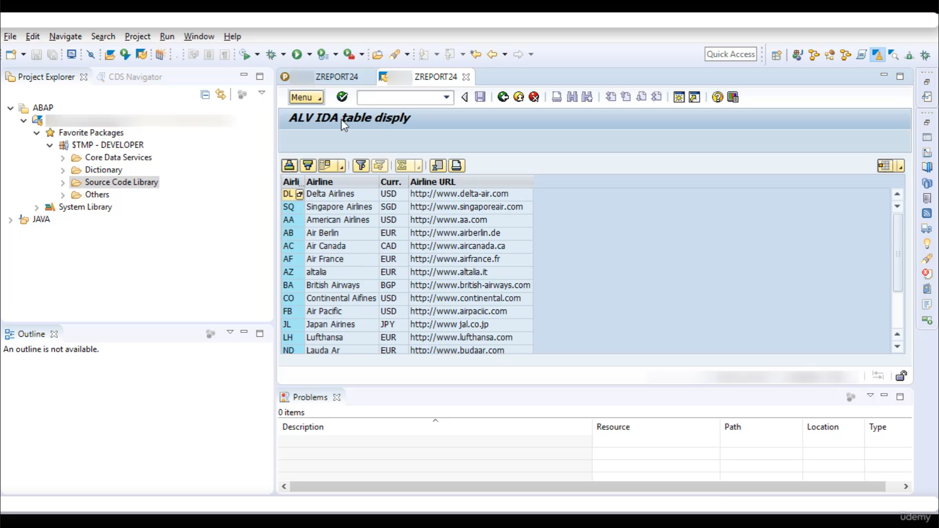

Now, let's get it for our program.

Let's give it Nimetz, the property for.

And let's give a description at Alimi only display.

Here in this report, we will write code to display content in.

Scott.

So let's right good, first of all, you have to create evidence to interface SLV, you were able idea.

Then use class to table idea to do call the static meter create.

And here you are to pass table name that you want to display.

So I want to display content in the table.

Scott's name, Scott.

Then you have to collect created instant.

Then using instant's always will be your call to Mr..

Full screen and then two meter display.

OK, so there is no error, so we can activate this one.

And now let's put it.

And here is the output.

It's very simple to use it little be tried to display quantity paper.

That's it for now.

Have a nice day.